Bahria University,

Karachi Campus



LAB EXPERIMENT NO.

3

LIST OF TASKS

|  |  |
| --- | --- |
| **Task No** | **Objective** |
| 1 | Display Product’s name and their supplier’s name (ContactName), whose supplier’s name doesnot contain Dirk and there should be at most 7 characters in Product’s name. |
| 2 | Create a report showing order ID. OrderDate. EmployeeID, and the firstname and LastName of the associated Employee |
| 3 | List distinct cities from of customers and suppliers, country must be Germany. |
| 4 | List all cities (duplicate values allowed)from of customers and suppliers |
| 5 | lists all customers and suppliers |

Submitted On:

12/4/2022

(Date: DD/MM/YY)

# Task# 01:- Display Product’s name and their supplier’s name (ContactName), whose supplier’s name does not contain Dirk and there should be at most 7 characters in Product’s name.

**Query:-** select products.productname,suppliers.contactname from products inner join

suppliers on products.supplierid = suppliers.supplierid where suppliers.contactname not like '%dirk%' and len(products.productname) < 8

# Output:-

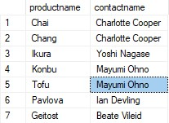

# Task # 02: Create a report showing order ID. OrderDate,EmployeeID, and the firstname and LastName of the associated Employee

# Query:-

select

orders.orderid,orders.orderdate,employees.employeeid,employees.firstname,employees.lastname from orders inner join employees on orders.EmployeeID = Employees.EmployeeID

# Output:-

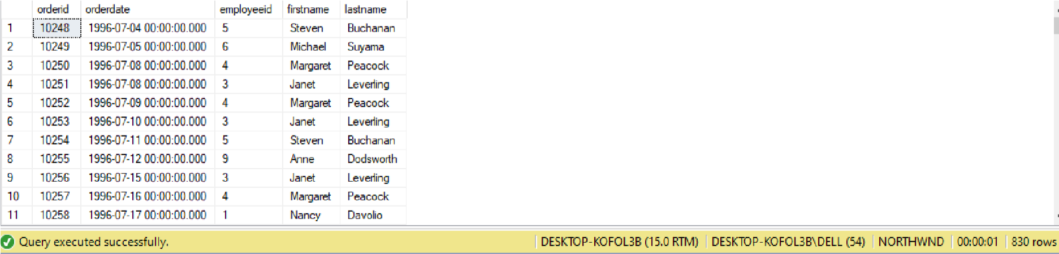

# Task#03:- List distinct cities from of customers and suppliers, country must be Germany.

**Query:-** select city from customers where country = 'Germany' union select city from suppliers

where country = 'Germany'

# Output:-

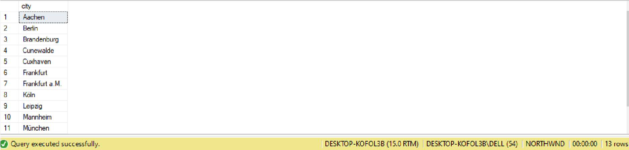

# Task# 04:- List all cities (duplicate values allowed)from of customers and suppliers

# Query:-

select city from customers union all select city from Suppliers

# Output:-

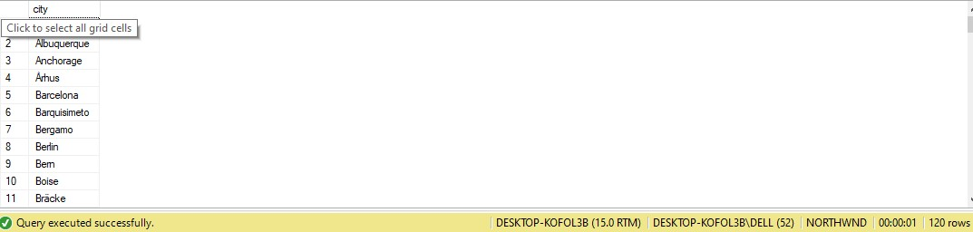

# Task# 05:- Lists all customers and suppliers

# Query:-

select 'Customer' as type,contactname,city,country from customers union select 'Supplier' as type,contactname,city,country from suppliers

# Output:-

